21.75: a) 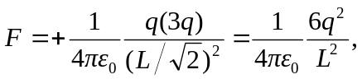toward the lower the left charge. The other two forces are equal and opposite.
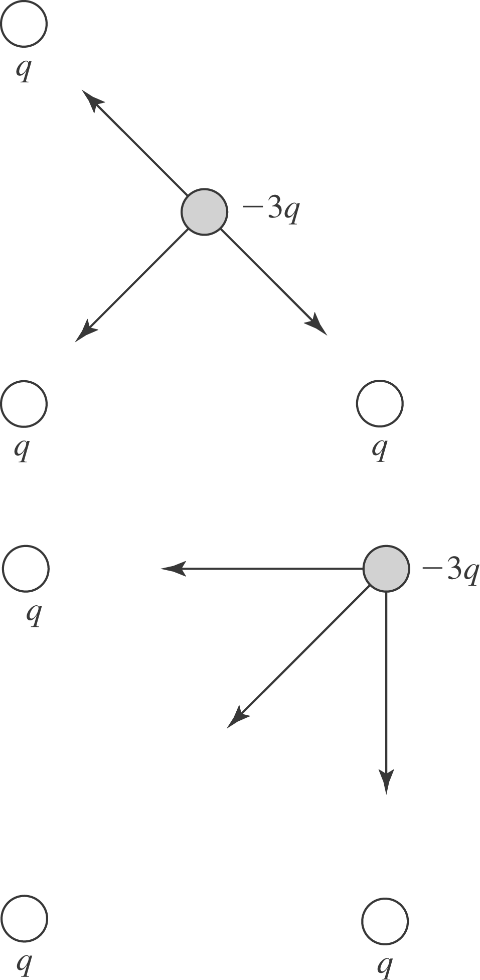

b) The upper left charge and lower right charge have equal magnitude forces at right angles to each other, resulting in a total force of twice the force of one, directed toward the lower left charge. So, all the forces sum to:
